RENCONTRES AU COEUR DU MEKONG VERSION 15 MARS 2026
INCHANGÉ
UT QUYNH HOMESTAY

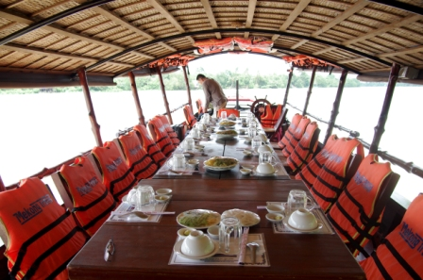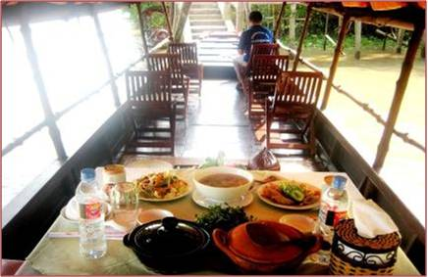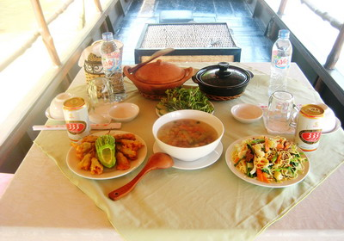

DAY | FROM | TO | BY | Km | TIME | ITINERARY
1 |  |  |  |  |  | SAIGON – VINH LONG (LD)
1 | Saigon | Mekong | Car | 120 | 0800 | Leave Ho Chi Minh City for Tien Giang province.
1 |  | Cai Thia | Bike  /walk |  | 1015 | Upon arrival cycle/walk along the canal with serene countryside. Walk 30min to explore the famous village of Hoa Loc mango on small lanes. Discover the beauty of countryside, thatched roof houses, witness daily life and activities along the river meet people...
1 |  |  |  |  |  | Stop at a traditional Mekong Delta house to see how to make rice paper. Tasting and have a cup of hot tea.
1 |  | An Binh Hoa Ninh | Boat |  | 1200 | Board your boat and have lunch while cruising to An Binh – Hoa Ninh (1hr)
1 |  |  | Sampan |  | 1300 | Take a sampan rowing (20min) around small creeks.
1 |  |  |  |  | 1320 | Walk (15min) to explore the serene countryside.
1 |  |  |  |  | 1340 | Arrive the homestay and check in.
1 |  |  |  |  |  | Relax.
1 |  |  | Walk | ~2 | 1500 | In the afternoon, you can relax or walk around the islet, meeting people.
1 |  |  |  |  | 1700 | Take part in dinner preparation with the host.
1 |  |  |  |  | 1900 | Dinner at homestay (included)
1 |  |  |  |  |  | O/N UT QUYNH HOUSE
2 |  |  |  |  |  | VINH LONG – BIKING – SAIGON (BL)
2 | Island |  | Bike | 4 | 0800 | After breakfast, take a leisure biking tour around the island to see the morning daily life activities. Photo opportunities.
2 |  |  | Boat |  | 0900 | Cross the river by boat.
2 |  |  |  |  | 0920 | Visit the Vinh Long market.
2 | Vinh Long | Saigon | Car | 140 | 0950 | Car drive back to Saigon.
2 |  |  |  |  | 1230 | Lunch en route (included)
2 |  |  |  |  | 1430 | Arrive Saigon and transfer to hotel. End of services.

RENCONTRES AU COEUR DU MEKONG VERSION 15 MARS 2026
INCHANGÉ
UT TRINH BEN TRE

DAY | FROM | TO | BY | Km | TIME | ITINERARY
1 |  |  |  |  |  | SAIGON – BEN TRE - TAM HIEP (LD)
1 | Saigon | Ben Tre | Car | 100 | 0800 | Leave Ho Chi Minh City for Ben Tre province.
1 |  | An Hoa | Walk  Boat  Boat  Sampan |  | 1000  1100  1130 | Arrive at An Hoa bridge.  Walk / Cruise to the workshop to see how the local people peeling-spliting-paring coconut by traditional ways. Visit a local factory with many kilns, see how they make charcoal from coconut hard-shell.  Continue crossing the Mekong river to Tam Hiep island.  Take a sampan rowing around small creeks.
1 |  |  |  |  | 1200 | Check in the homestay and have lunch.
1 | Homestay |  | Walk |  | 1500 | Walk under the shade of longan trees to visit a farm planting ginseng leaf. The owner’s farm will show you how to make jelly with these leaves. A good taste!
1 |  |  | Bike |  | 1545 | Biking tour on village paths to visit bonsai garden, bee farm…
1 |  |  | Bike |  | 1700 | Cycle back to homestay for a fresh shower.
1 |  |  |  |  | 1800 | Take part in dinner preparation with the host.
1 |  |  |  |  | 1900 | Dinner with the lovely host.
1 |  |  |  |  |  | O/N UT TRINH BEN TRE HOUSE
2 |  |  |  |  |  | TAM HIEP – BIKING – SAIGON (BL)
2 | Island |  | Bike | 4 | 0830 | After breakfast, take a leisure biking tour around the island to see the morning daily life activities. Photo opportunities.
2 |  |  | Boat |  | 1000 | Visit local market, school, workshop of fabric for carpets.  Check out.
2 |  |  |  |  | 1030 | Cross the river by boat and visit the famous Long Thanh Communal House.
2 |  | Saigon | Car | 100 | 1115 | Car drive back to Saigon.
2 |  |  |  |  |  | Lunch en route (included)
2 |  |  |  |  | 1500 | Arrive Saigon and transfer to hotel. End of services.

RENCONTRES AU COEUR DU MEKONG VERSION 15 MARS 2026
INCHANGÉ
MEKONG HOME

DAY | FROM | TO | BY | Km | TIME | ITINERARY
1 |  |  |  |  |  | SAIGON – MEKONG HOME (LD)
1 | Saigon | Mekong Home | Car | 100 | 0800 | Leave Ho Chi Minh City for Ben Tre province.
1 |  |  |  |  | 1030 | Arrive in a charming village, hidden under hundreds of coconut palm trees. Welcome at Mekong Home, charming familial house composed of several bungalows, set in a tropical garden and on the Mekong river bank.  Welcome drink before check-in.
1 |  |  |  |  | 1130 | Lunch at Mekong Home (included)
1 | Mekong Home | Oc island | Bike | 9 | 1430 | Afternoon start 2hrs cycling trip to the island of Oc on a concrete track, lined with fruit trees and coconut trees, witness daily life, encounter with locals. Stop at a fish farm, get to know about two main species of catfish production in Vietnam.
1 | Oc island | Mekong Home | Boat |  | 1630 | Board the boat and cruise 30min along the river. A fresh fruit juice and cookies are served on board while the boat splits the waves towards the Lodge.
1 |  |  |  |  | 1700 | Disembark at Mekong Home dock.
1 |  |  |  |  |  | Refresh at leisure.
1 |  |  |  |  | 1900 | Participate in a cooking demonstration of “banh Xeo”, Vietnamese pancake made from rice milk following by a typical dinner (included)
1 |  |  |  |  | 2030 | After dinner, relax by lemongrass and ginger foot bath, a local therapeutic method to relieve the pain and fatigue of the legs.
1 |  |  |  |  |  | O/N MEKONG HOME
2 |  |  |  |  |  | MEKONG HOME – SAIGON (BL)
2 |  |  |  |  |  | Breakfast at Mekong Home.
2 | Mekong Home |  | Walk | 1 | 0900 | Visit a local market where various of local ingredients as vegetable, meat, fruits... are sold.
2 |  | Ben Tre | Car | 10 | 1000 | Depart for Ben Tre. Visit the market on arrival.
2 |  | Saigon | Car | 100 | 1030 | Continue to Saigon with stop to visit the coconut candy factory.
2 |  |  |  |  |  | Lunch en route.
2 |  |  |  |  | 1500 | Arrive Saigon and transfer to hotel. End of services

